TASK 1:
Cpp file:
#include <iostream>
using namespace std;
extern "C" {
void calculateProduct();

void displayProduct(int num1,int num2,int num3, int result);
}

int main() {
calculateProduct();
return 0;
}

void displayProduct(int num1, int num2, int num3, int result) {
cout << "The product of " << num1 << ", " << num2 << " and " << num3 << " is: " << result << endl;
}
ASM File:
INCLUDE Irvine32.inc
calculateProduct PROTO C
displayProduct PROTO C, num1:DWORD, num2: DWORD, num3: DWORD, result: DWORD
.data
number1 dword 4
number2 dword 5
number3 dword 6
.code
calculateProduct PROC C
mov eax, number1
mov ebx, number2
mov ecx, number3
imul eax, ebx
imul eax, ecx
INVOKE displayProduct, number1, number2, number3, eax
ret

calculateProduct ENDP
END

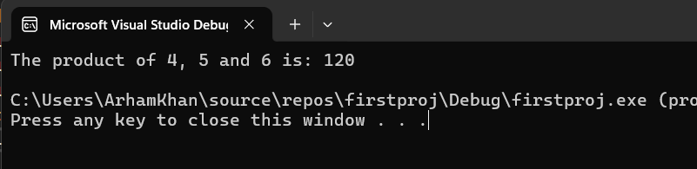
TASK 2:
CPP code:
#include <iostream>
using namespace std;

extern "C" {
void calculateGCD();
int askForInteger();
void displayGCD(int num1, int num2, int gcd);
}

int main() {
calculateGCD();
return 0;
}

int askForInteger() {
int n;
cout << "Enter a positive integer: ";
cin >> n;
return n;
}

void displayGCD(int num1, int num2, int gcd) {
cout << "GCD of " << num1 << " and " << num2 << " is: " << gcd << endl;
}

ASM FILE:
INCLUDE Irvine32.inc
calculateGCD PROTO C
askForInteger PROTO C
displayGCD PROTO C, num1:DWORD, num2: DWORD, gcd: DWORD

.data
numA dword ?
numB dword ?
.code
calculateGCD PROC C

INVOKE askForInteger
mov numA, eax
INVOKE askForInteger
mov numB, eax
mov ebx, numB
mov eax, numA
gcd_loop:
cmp ebx, 0
je gcd_done

mov edx, 0
div ebx
mov eax, ebx
mov ebx, edx
jmp gcd_loop

gcd_done:

INVOKE displayGCD, numA, numB, eax
ret

calculateGCD ENDP
END
